**Purpose/Goal**

Flight delay is the serious and extensive problem in United States. Increasing flight delays place a significant strain on the U.S. air travel system and cost airlines, passengers and society many billions of dollars each year. According to Federal Aviation Administration (FAA), the total cost of air transportation delay in 2007 is approximately **$31.2 billion**. This includes $16.7 billion direct cost to passengers. Flight delay also has indirect effect on U.S economy. Our study/Analysis will help the FAA to predict the airline arrival delay so that they can make the precautionary action to avoid/reduce the cost incurred due to flight delays. Below are the objectives of our analysis.

* Which airline and airport has the highest delay time?
* Predicting the arrival delay and identifying the factors which influence the delay.
* Which day of the month in a year has the highest delay time?

**About data**

This analysis is based on the sample data collected from the population comes originally from The U.S. Department of Transportation's (DOT) Bureau of Transportation Statistics (BTS) for the year **2008**. We have sampled the data based on carrier and originating airport with the equal proportion of each category. The sample has **10,997 rows** and **21 columns** which contains the data for five popular airlines (Alaska Airlines Inc., JetBlue Airways, Delta Air Lines Inc., Hawaiian Airlines Inc., Southwest Airlines Co.) and five origin Airports (Chicago O'Hare, Dallas/Fort Worth, Denver, Hartsfield–Jackson Atlanta, Los Angeles). Description of variables can be found in *appendix section A.1.*

*Initial analysis of the data*

* We observed that variables ArrivalTime, and ArrivalDelay have about 0.28% of missing data and ActualElapsedTime, AirTime, ArrivalDelay, and TaxiIn have about 0.37% of missing data. Hence, we imputed the median to the missing fields across the columns.
* Columns such as Departure Time, Scheduled Departure Time, Arrival Time, Scheduled Arrival time were in ‘hhmm’ format. Hence these columns are normalized to minutes.

**Methods and Tools**

Below are the methods and tools used for the analysis;

* + Descriptive Statistics
  + Normal distribution, Histograms, ANOVA, Multiple Linear Regression, Factor Analysis
  + Correlation
  + Python, JMP, and Tableau

**Analysis**

Before we initiate our analysis let’s do some exploratory data analysis which will help us to better understand the data. Rather than exploring on all the variables let’s assume the significant factors which may influence our objectives. Below are the descriptive statistics for the variables.

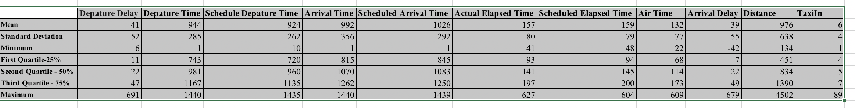

Let’s get started with findings from this statistic:

**Departure Delay**

|  |  |  |  |
| --- | --- | --- | --- |
| **Count** | **Mean** | **Median** | **Standard Deviation** |
| 10997 | 41 | 22 | 52 |

Breaking down the above fundamental statistics,

***Count:*** Number of records collected for the sample is 10,997.

***Mean:*** The average departure delay time is 41 minutes. We could say if the Departure delay is more than 41 minutes, then the flight is delayed. But practically passengers will lose the patient if they need to wait for so long.

***Median:*** The median is the center point in the dataset. Comparing the mean of 41 minutes and median of 22 minutes lead to the suspicion that the data may have outliers. Hence, we could assume mean is influenced by outliers and delay time of 22 minutes derived from median is acceptable.

***Standard Deviation:*** This tells how spread the data are from the mean. The Std.Dev of 52 shows that about 68% of departure delay fall within one standard deviation.

75% of the data (Departure delay) falls within 47 minutes. However, the maximum value of 691 minutes tells us the data is **right skewed**. This can be clearly seen in the histogram plot shown in *appendix section A.2.*

Other variable follows similar break down with the difference in the value. Hence going forward, we will highlight the major findings for other rating sites.

**Departure Time**

Most of the flights start departing from 720th minutes of each day. The frequency of flight departures is less during the start of the day. Hence, we could say the data is **left skewed**.

**Scheduled Departure Time**

Distribution of Scheduled Departure Time is almost similar to Departure Time.

**AirTime**

On an average the duration of travel is 132 minutes and 75% of flight duration is within 173 minutes which substantiate that the distribution is **right skewed**. Since the air time depends of Distance between origin and destination we could say, Air Time and Distance should be highly corelated. However, airtime may be influenced by other factors like weather.

**Arrival Delay**

Less than 10% of the time the flight arrived at the destination earlier than the scheduled arrival time. However, the arrival delay follows the same distribution as departure delay. Hence, it is evident that the flight departing late will arrive late. The average arrival delay is 39 minutes which is close to average departure delay. For instance, the 10 minutes delayed departure will cause 10 minutes delay in arrival. Departure delay is the most influencing factor for predicting Arrival delay.

The distribution of these variables can be seen in *appendix A.2.*

***Which airline and airport has the highest delay time?***

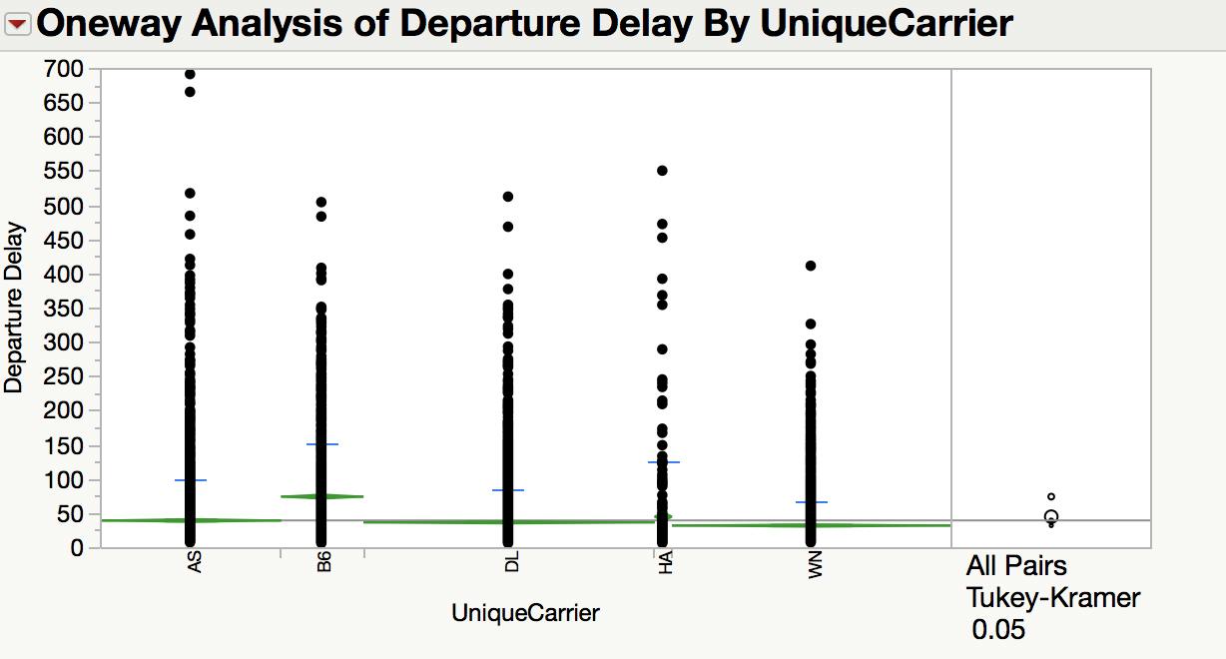To determine which airline has the highest departure delay and arrival delay, ANOVA was performed on the data set. Initially we performed ANOVA on departure delay based on airport. From the analysis, we found that the **unequal variance assumption failed** due to less p-value (**0.0001)** of levene’s test. Hence, we considered the p-value (0.0001) of Welch’s Test to continue our analysis.

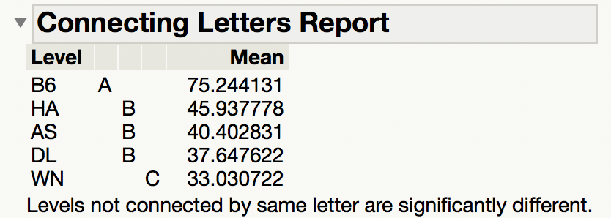From the analysis of variance and connecting letter report, we have observed that ***Jet blue (B6)*** has the highest average departure delay time of **75 minutes** compared to other airlines. There is no significant difference exist between other airport except Jet blue.

Similarly, ***Chicago O'Hare international airport (ORD)*** has the highest departure delay time of **72 minutes** compared to all other airports. *See the appendix A.3* for ANOVA output. We considered the Welch’s test p-value for our analysis since the **unequal variance assumption failed.**

Since, the ***Jet blue (B6)*** and ***Chicago O'Hare international airport (ORD)*** has the highest departure delay, we could say this airline and airport will have the highest **arrival delay**. This can be evidently seen from the below report from Tableau. Both Jet Blue (B6) and Chicago O'Hare international airport (ORD) are **often delayed on Thursday** with average arrival delay time of **62 minutes.**

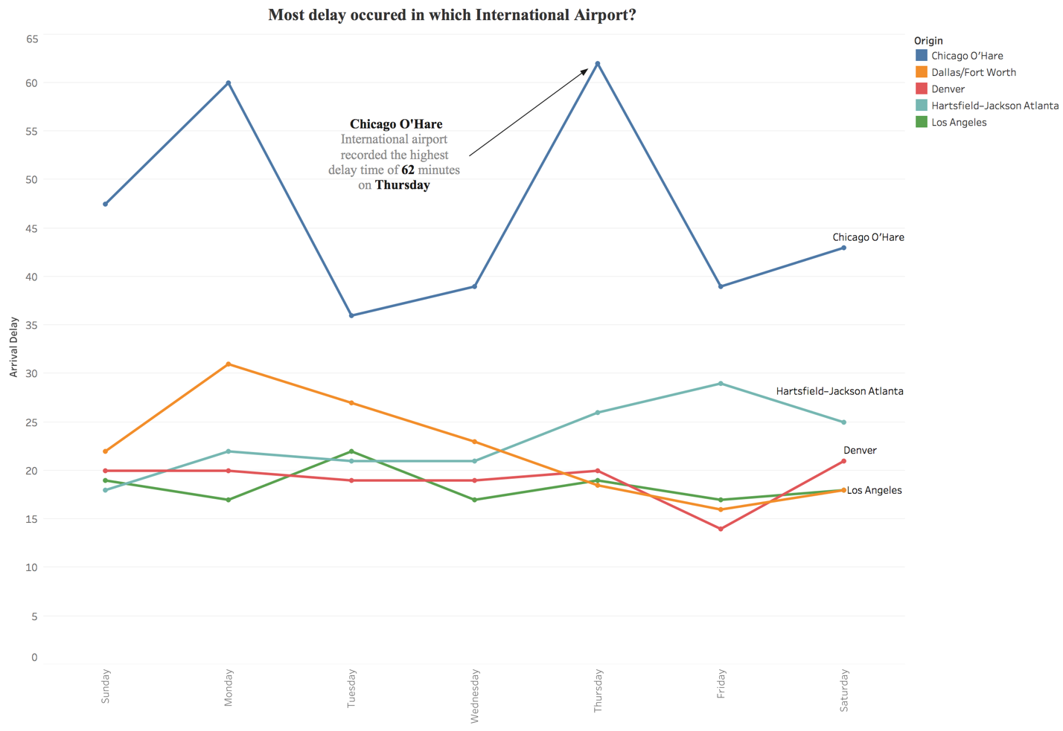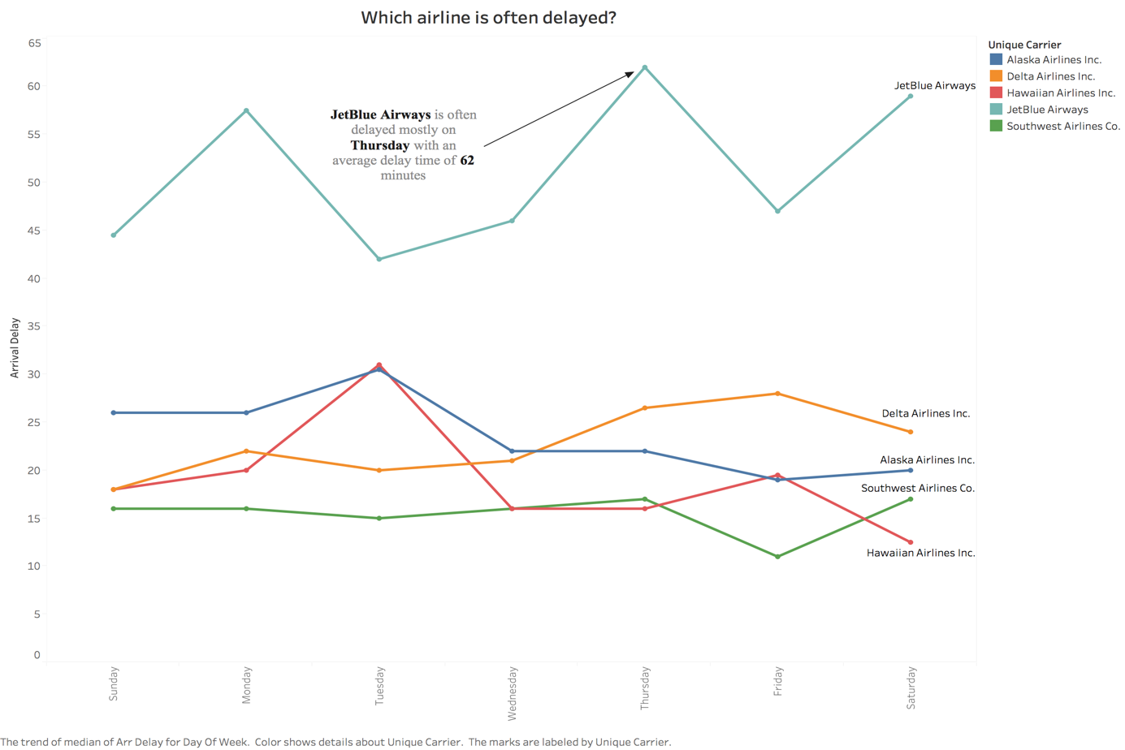

***Predicting the arrival delay and identifying the factors which influence the delay.***

Before building the model to predict the arrival delay, lets identify the influencing factors which are correlated with the variable Arrival Delay.

*See appendix A.4* for pair plot and correlation matrix. From the two graph, it is evident that Departure Delay is highly corelated with arrival delay. It has the correlation value of **0.95** (i.e.) 95% of variability in arrival delay can be explained Departure delay. Hence, it is one of the most influencing factor to predict the arrival delay. We could also see the independent variables such as ActualElapsedTime, AirTime, Distance, and CRSElapsedTime are highly corelated. This cause the suspicion of multicollinearity. We used the VIF value to check the multicollinearity between these variables.

We used multiple linear regression to predict the model. In the initial analysis, we observed that, except Departure Delay, ActualElapsedTime, CRSElapsedTime, AirTime, Distance, and TaxiIn, all the other variables are not significant to the model since the p-value is greater than 0.05. Hence, we removed those variables from the model and identified the below model with below model with RSquare value of **0.98 (98%).**

**Model 1:**

**Arrival Delay = -5.56 + 0.99 * Departure Delay + 0.97 * ActualElapsedTime – 0.71 * CRSElapsedTime – 0.31 * AirTime + 0.005 * Distance – 0.05 * TaxiIn**

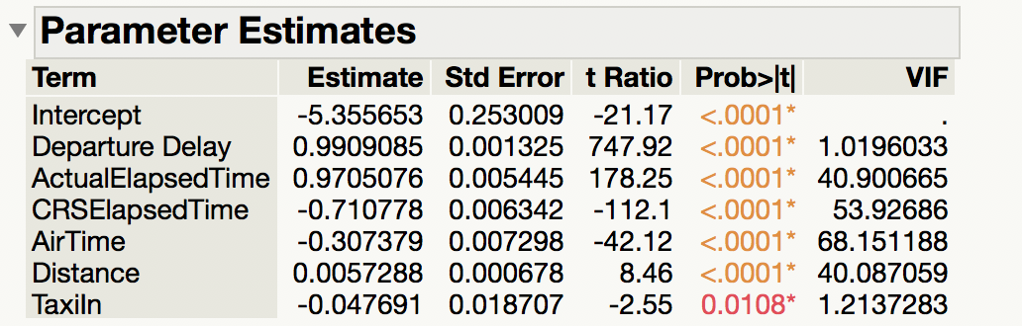The ANOVA **p- value (0.0001)** for this model is less than 0.05 and all the independent variables are significant. However, as stated above multicollinearity exist between the variables ActualElapsedTime, CRSElapsedTime, Airtime, and Distance, since the **VIF** value is greater than **5.0** (The threshold value we used in the model).

Since, we have multicollinearity exist between the variables, the above model is not adequate. Hence, we used backward elimination process to remove these variables from the model.

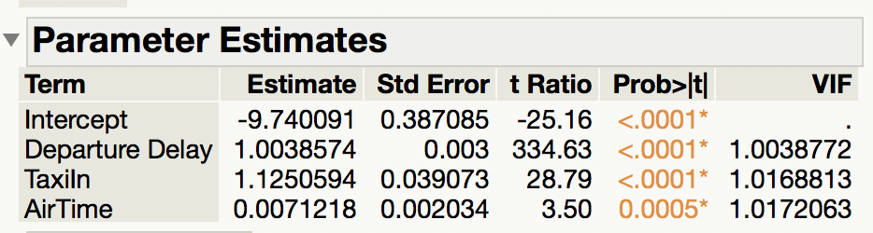After removing the variable ActualElapsedTime, CRSElapsedTime, and Distance, the VIF value of Airtime reduced to **1.02.**

**Model 2:**

**Arrival Delay = -9.74 + 1.00 * Departure Delay + 1.13 * TaxiIn + 0.01 * AirTime**

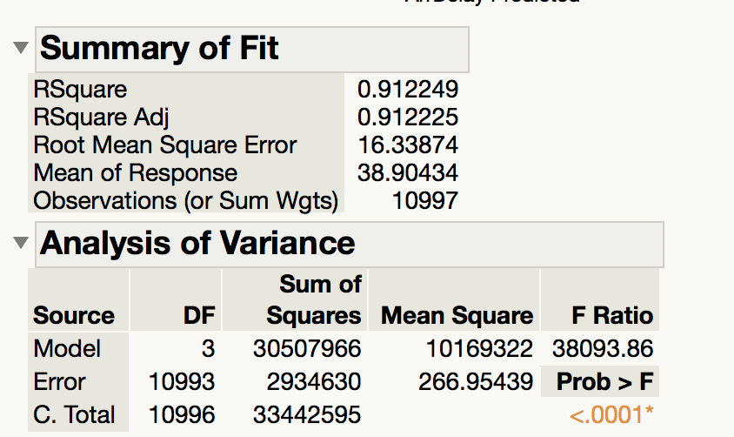The above model is adequate with RSquare value of **0.91.** (i.e. **91%** of the variability of Arrival delay can be explained by these Departure Delay, TaxiIn, and AirTime). Even though the RMSE value (16.33) is high compared to previous model (RMSE: approx. 7), this model is model stable since all the multiclonality variables are removed.

*Interpreting the coefficients*

For every one-minute increase in Departure Delay, Arrival delay will increase by **one minute.**

For every one-minute increase in TaxiIn, Arrival delay will increase by **1.13 minute.**

For one-minute increase in AirTime, Arrival delay will increase by **0.01 minute.**

*PCA / Factor Analysis*

Before concluding model 2 is the best model to predict the arrival delay, let’s do PCA / factor analysis to reduce the multicollinearity between these variables.

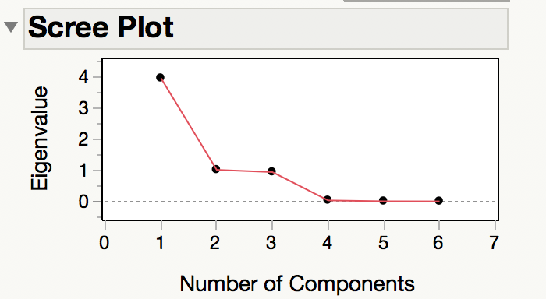Let’s determine the number of components to be used to our analysis using scree plot.

As per the scree plot, let’s try with 2 factors. Since the ChiSq value (0.0001) is less than 0.05, we need more factors. Hence, we try 4 factors.

The greater ChiSq value (**1.000**) suggest that 4 factors are sufficient for the analysis.

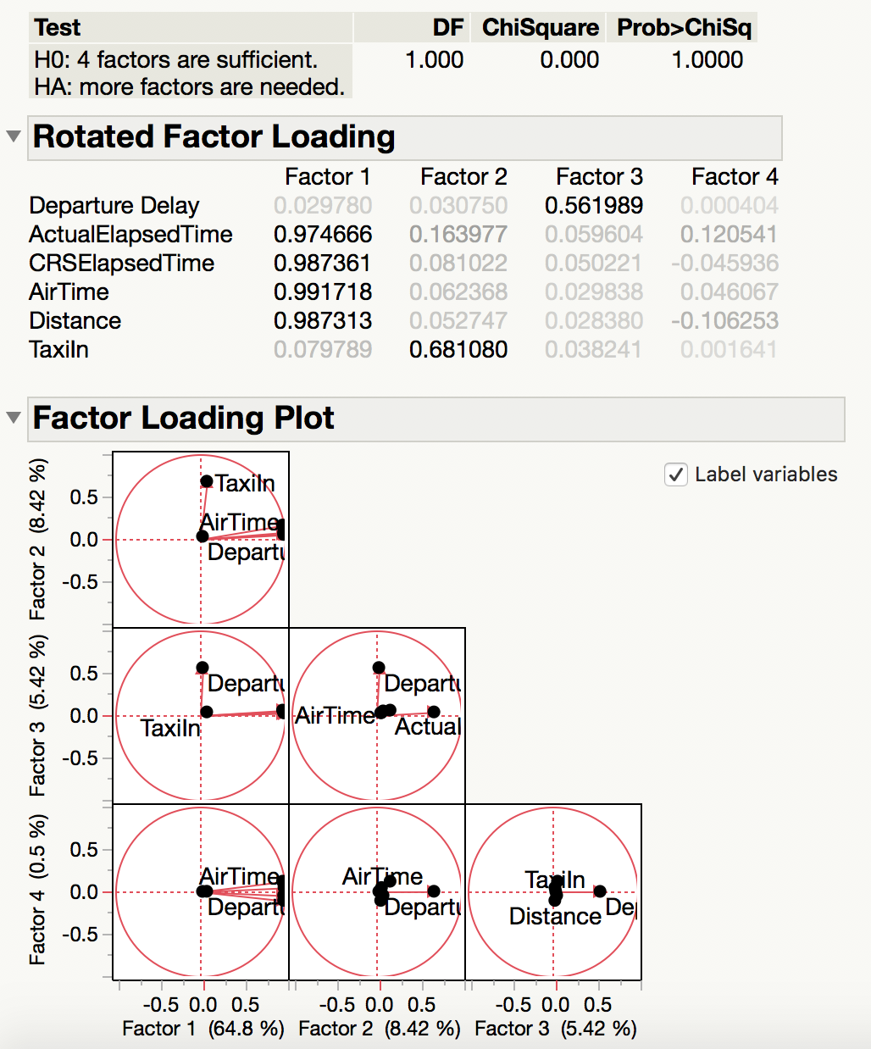As the factor values for the variables are greater than 0.50 except factor 4. factor 1, factor 2 and factor 3 are significant to run the MLR. Factor 1 explains 64.8 % variability.

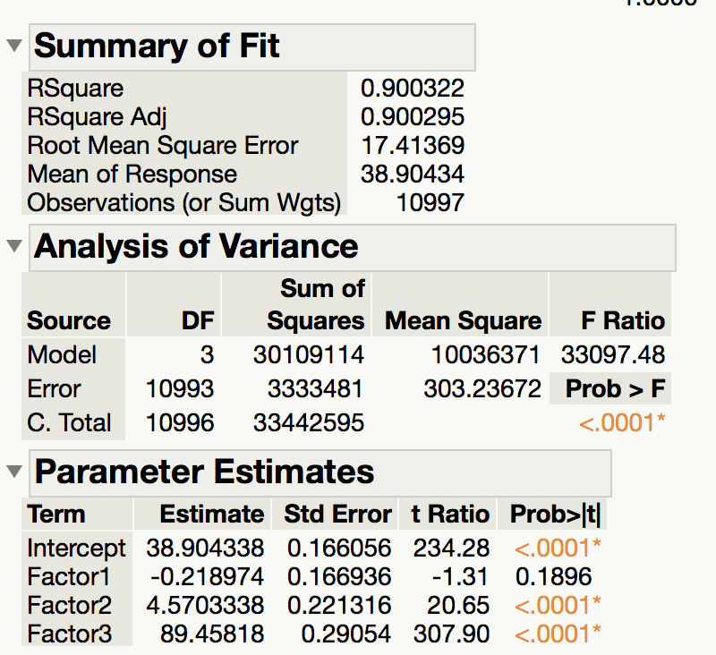We ran the MLR with these three factors identified. The overall model is significant as the ANOVA p-value is less than 0.05. This also has the high RSquare value of 0.90. However, the factor 1 is not significant to the model since, the p-value **(0.1896)** is high.

Hence, we removed this factor from the model and identified the below adequate model with RSquare value of **0.90** and all the factors are significant.

**Model 3:**

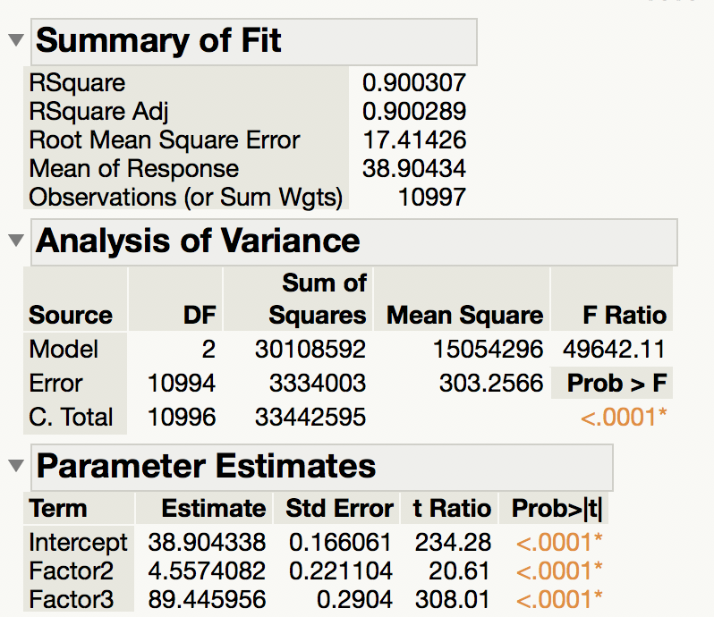**Arrival Delay = 38.90 + 4.55 * TaxiIn +89.45 * Departure Delay**

Even though, this model is adequate, **Model 2 is the best model** to predict the arrival delay. It has the highest RSquare value **0.91** with less RMSE value of **16.34** compared to model 3.

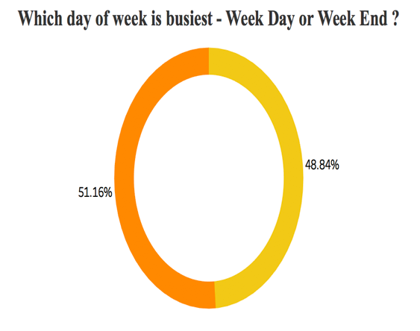***Which day of the month in a year has the highest delay time?***

Exploring the data, we observed that arrival delay in weekday is more compared to weekend. As seen in the figure, weekday has **51.16 %** of flight delay compared to 48.84% in weekend. However, this difference is not significant. On an average, 13th day of July has the highest delay time of 119 minutes in the year 2008.

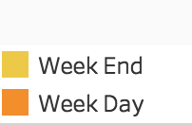

**Appendix**

*A.1 Variable Description*

|  |  |  |
| --- | --- | --- |
| **Variable descriptions** | | |
| **Sl. No** | **Name** | **Description** |
| 1 | Year | 2008 |
| 2 | Month | 12-Jan |
| 3 | DayofMonth | 31-Jan |
| 4 | DayOfWeek | 1 (Monday) - 7 (Sunday) |
| 5 | DepTime | actual departure time (local, hhmm) |
| 6 | CRSDepTime | scheduled departure time (local, hhmm) |
| 7 | ArrTime | actual arrival time (local, hhmm) |
| 8 | CRSArrTime | scheduled arrival time (local, hhmm) |
| 9 | UniqueCarrier | unique carrier code |
| 10 | FlightNum | flight number |
| 11 | TailNum | plane tail number |
| 12 | ActualElapsedTime | in minutes |
| 13 | CRSElapsedTime | in minutes |
| 14 | AirTime | in minutes |
| 15 | ArrDelay | arrival delay, in minutes |
| 16 | DepDelay | departure delay, in minutes |
| 17 | Origin | origin IATA airport code |
| 18 | Dest | destination IATA airport code |
| 19 | Distance | in miles |
| 20 | TaxiIn | taxi in time, in minutes |
| 21 | TaxiOut | taxi out time in minutes |

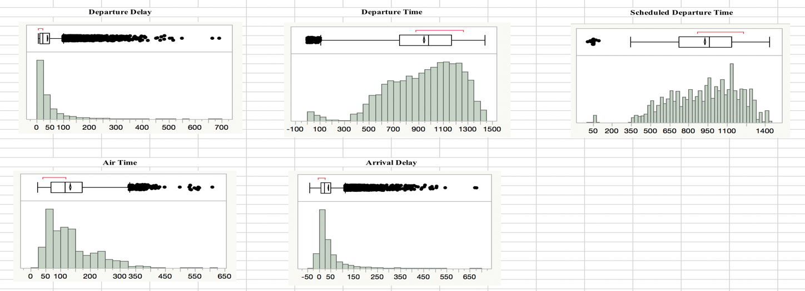*A.2 Histogram Plot*

*A.3 Analysis of Variance*

***One-way analysis of departure delay by Origin***

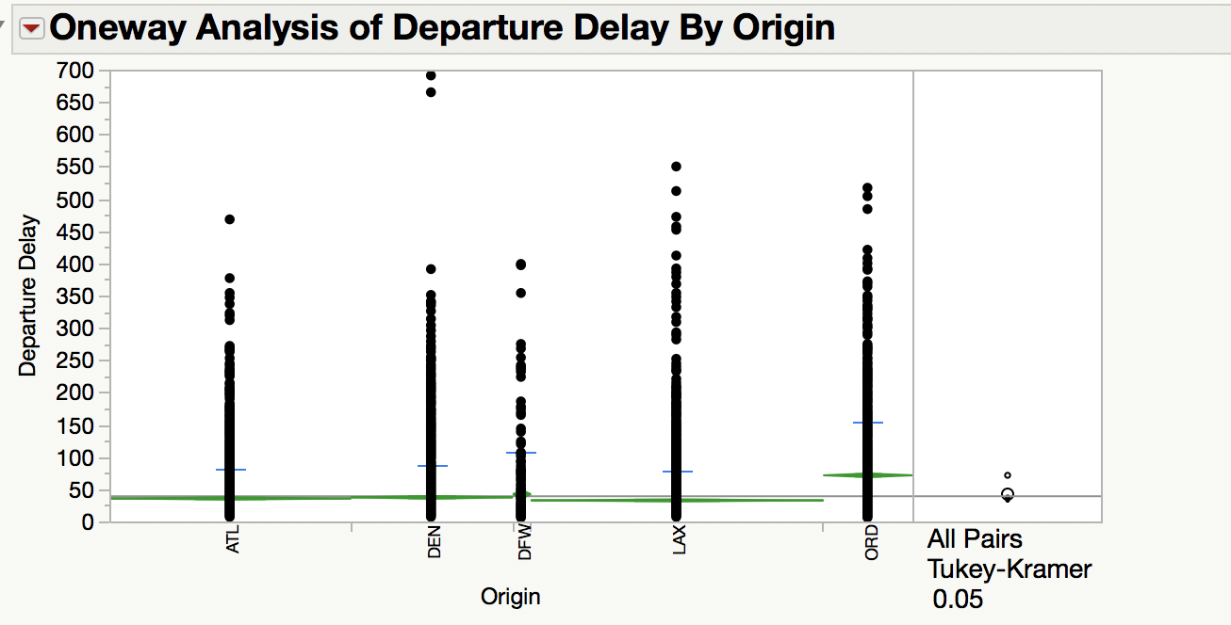

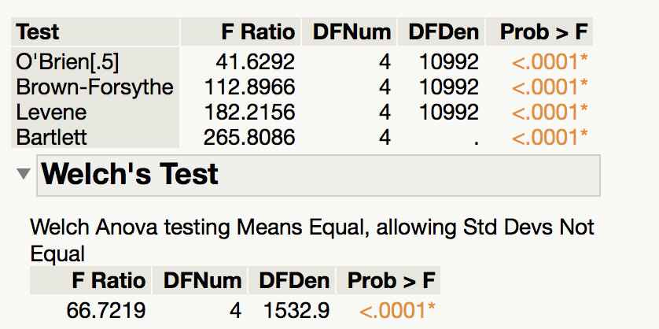

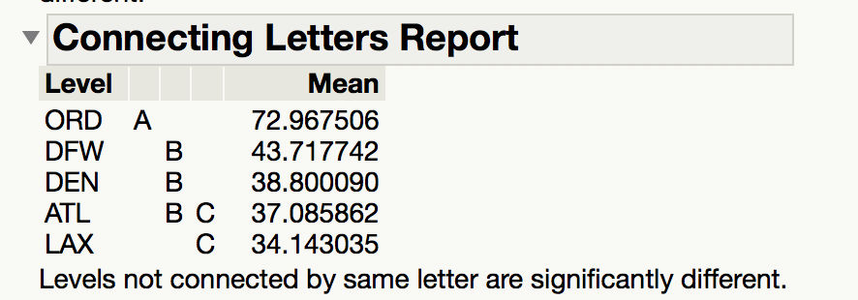

*A.4 Identifying the correlation between the variables*

*Pair Plot*

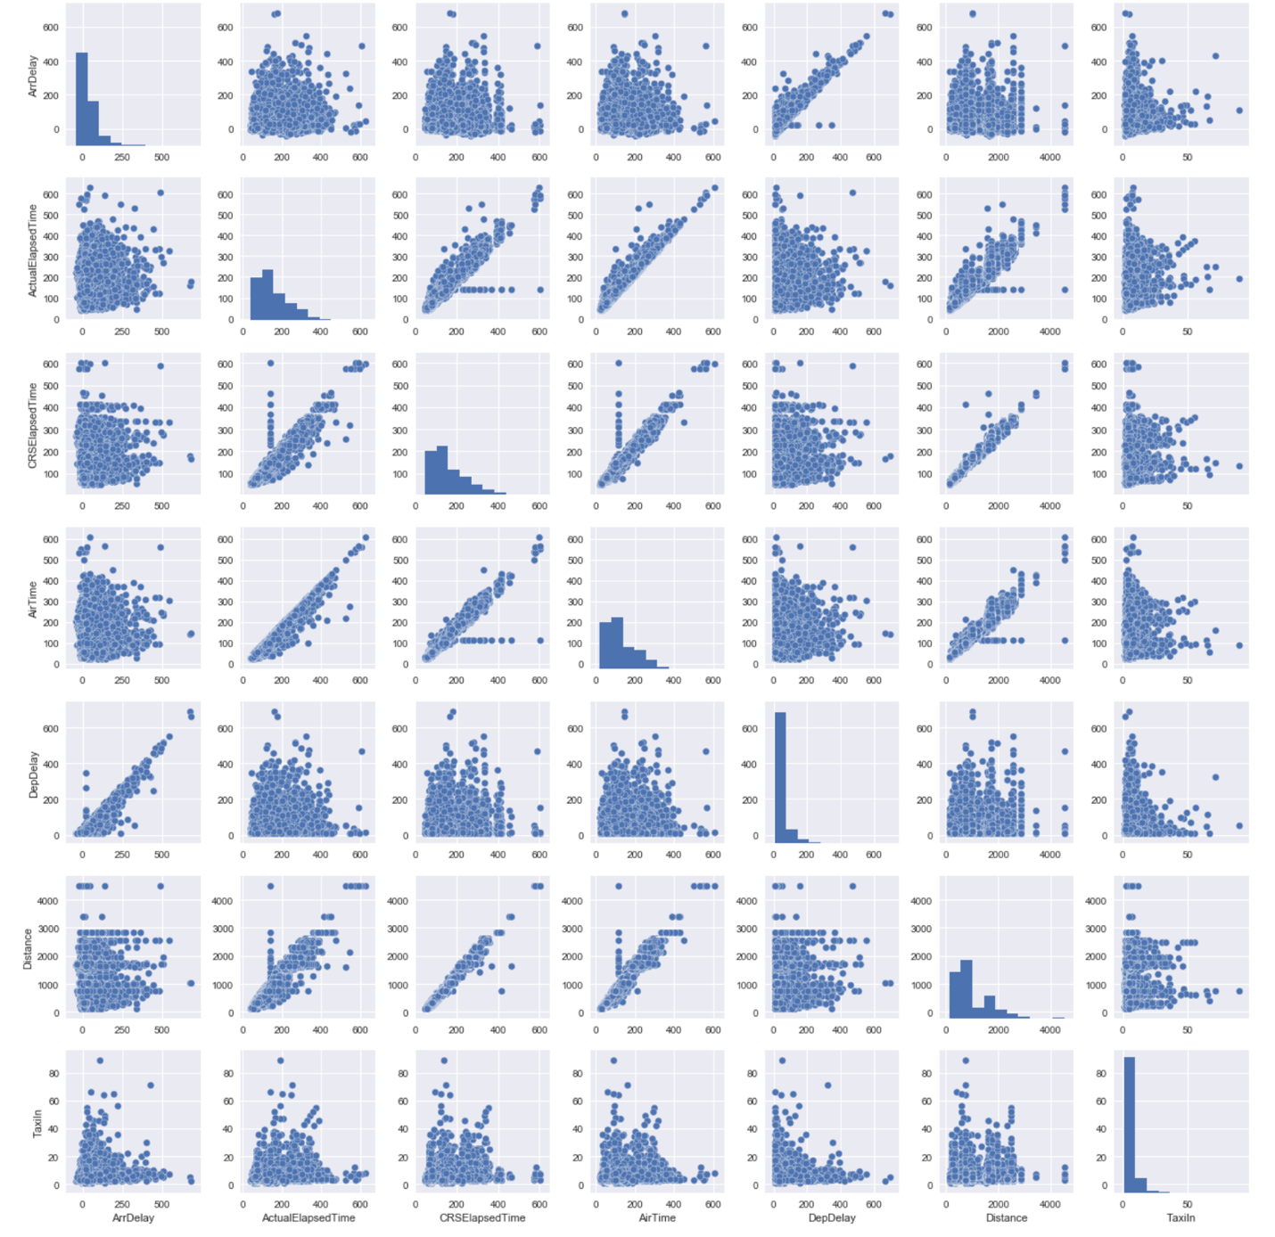

*Correlation Matrix*

